EXPT NO: 10 | Creating Basic Automation Task using UiPath Studio
DATE: 21.10.2025

PRE-LAB QUESTIONS (Write the answers in your AI and Automation Notebook)
- What is Robotic Process Automation (RPA), and how does it differ from traditional automation?
Robotic Process Automation (RPA) uses software bots to mimic human actions in digital systems, differing from traditional automation by requiring no code or deep system integration.

- What are the main components of UiPath Studio?
Main UiPath Studio components include Activities Panel, Properties Panel, Output Panel, and Workflow Designer for building, configuring, and debugging automation processes.

- What is the difference between Attended and Unattended Robots in UiPath?
Attended Robots work with human intervention on user machines, while Unattended Robots run autonomously on servers without manual input.

- List any three commonly used activities in UiPath Studio.
Three common UiPath activities are Click, Type Into, and Read Range, used for interacting with applications and managing data.

- How does UiPath help in automating repetitive business processes?
UiPath automates repetitive business tasks by recording workflows, integrating applications, and executing actions quickly and accurately, improving efficiency and reducing human error.

IN-LAB EXERCISE
OBJECTIVE:
To create, design, and execute a basic automation workflow using UiPath Studio.

PROCEDURE:
Part A – Setting Up the Environment
- Open UiPath Studio.
- Create a new Process Project (File → New → Process).
- Name the project (e.g., “BasicAutomationTask”).
- Set a suitable location for saving the project files.
- Click Create to initialize the UiPath workspace.

Part B – Understanding the UiPath Interface
Familiarize yourself with key UiPath Studio panels:
- Activities Panel – contains automation activities.
- Properties Panel – used to configure activity parameters.
- Output Panel – displays logs and messages.
- Variables Panel – for creating and managing workflow variables.
- Main Workflow Panel – the area where automation sequences are designed.

Part C – Building the Workflow
- Drag and drop a Sequence activity into the Main panel.
- Add required activities (e.g., Assign, Message Box, Input Dialog, Write Line).
- Use Variables to store and manipulate data within the workflow.
- Configure Properties for each activity.
- Save the workflow using Ctrl + S.

Part D – Executing and Debugging the Automation
- Click Run to execute the workflow.
- Observe the Output Panel for logs and results.
- If errors occur:
  - Use Breakpoints or Debug Mode.
  - Check Variable Types and Activity Properties.
- After successful execution, review the automation steps and confirm the results.

Part E – Publishing the Process (Optional)
- Go to the Design Tab → Publish option.
- Publish the project to UiPath Orchestrator or a Local Folder.
- Verify that the automation package is successfully created.

SCREENSHOTS OF WORKFLOW / PROCEDURE
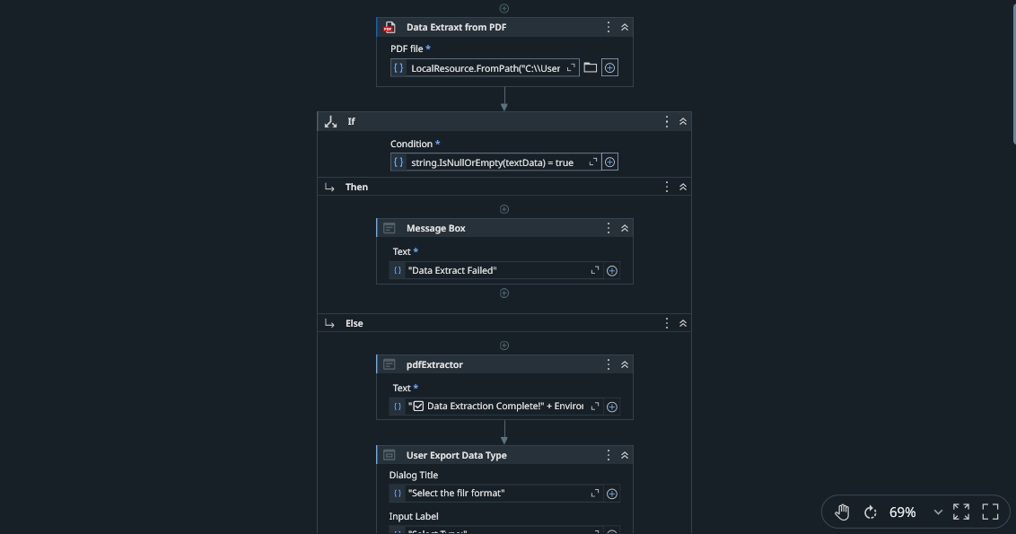

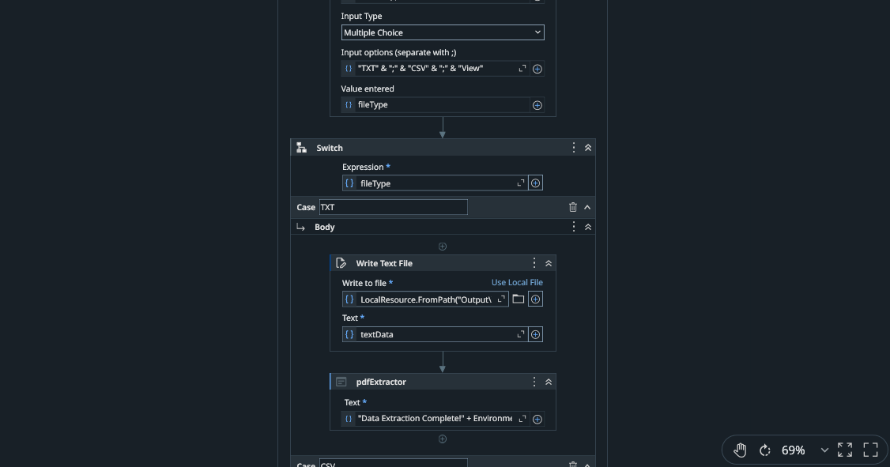

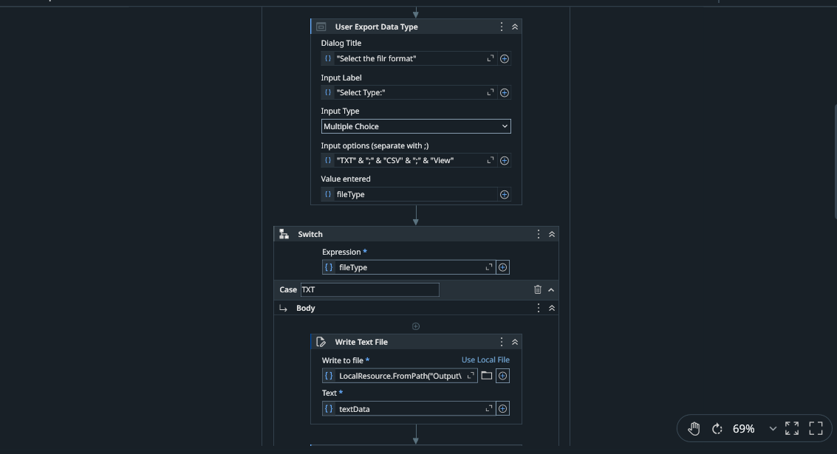

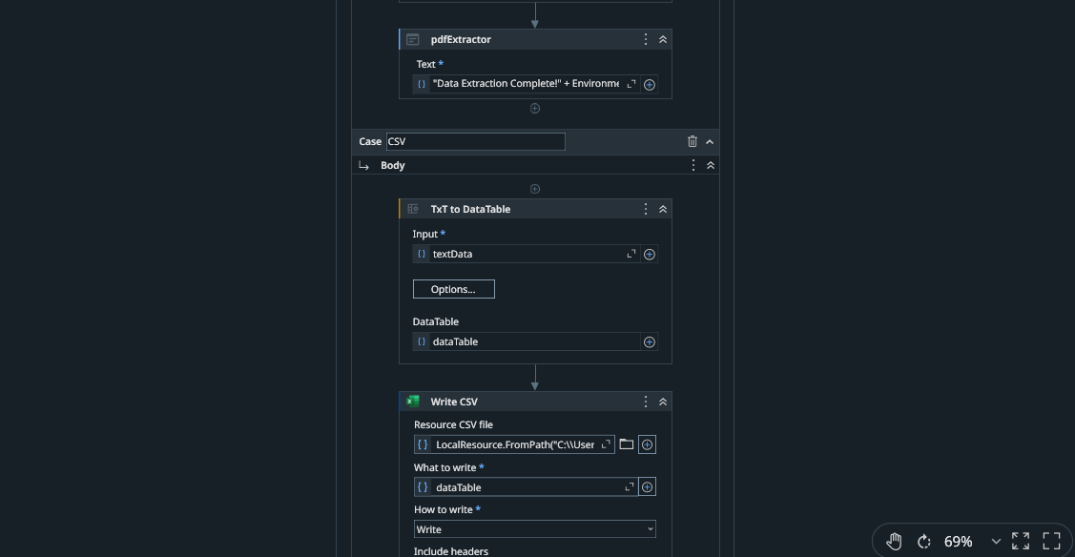

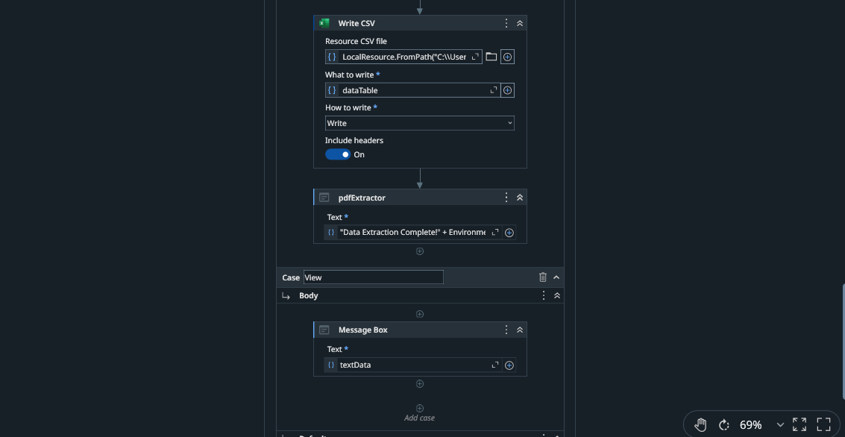

SCREENSHOT OF OUTPUT
Resources Used:
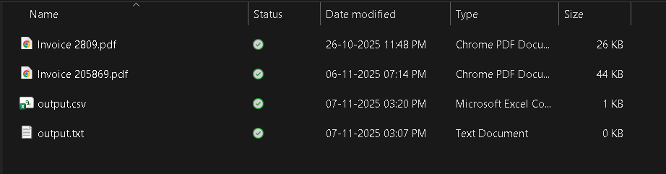

Invoice 2809.pdf
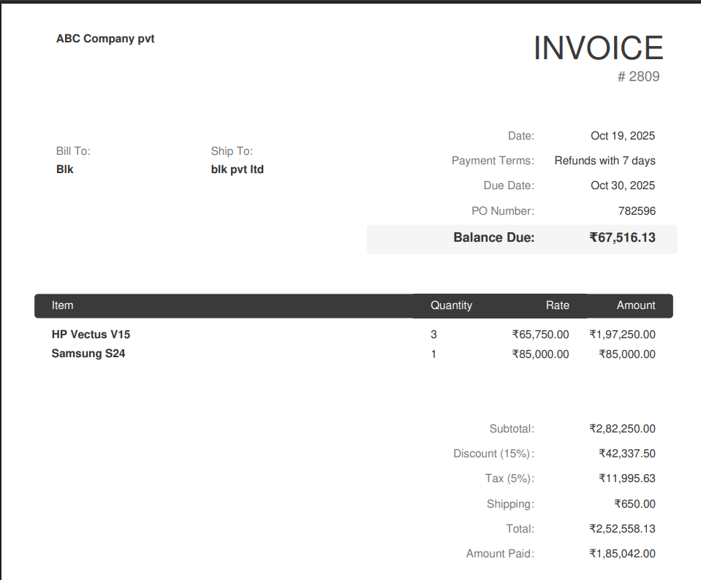

Output.txt(initial)
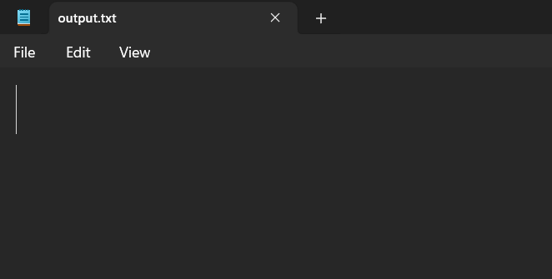

Output.csv(initial)
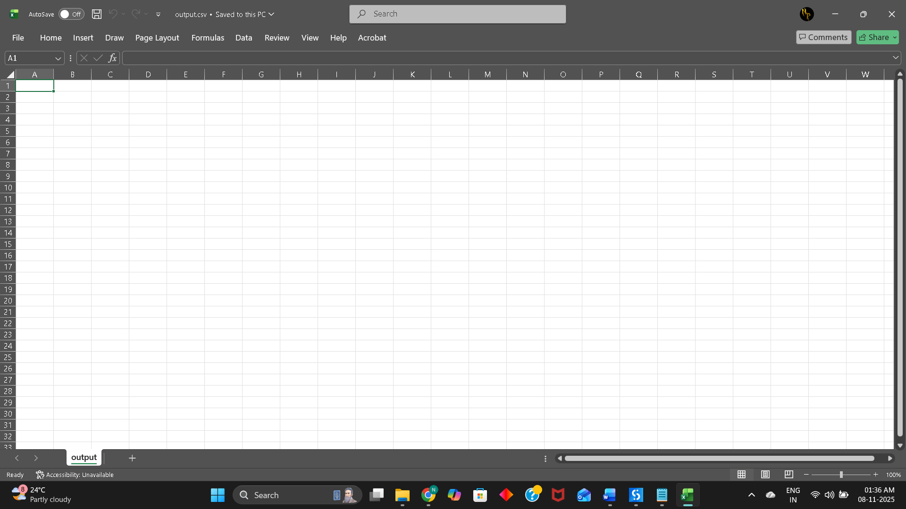

Process
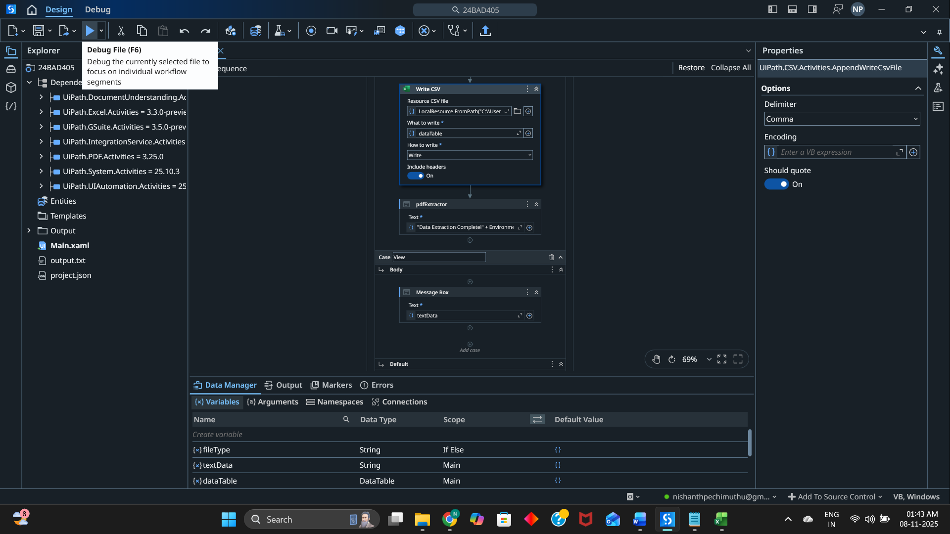

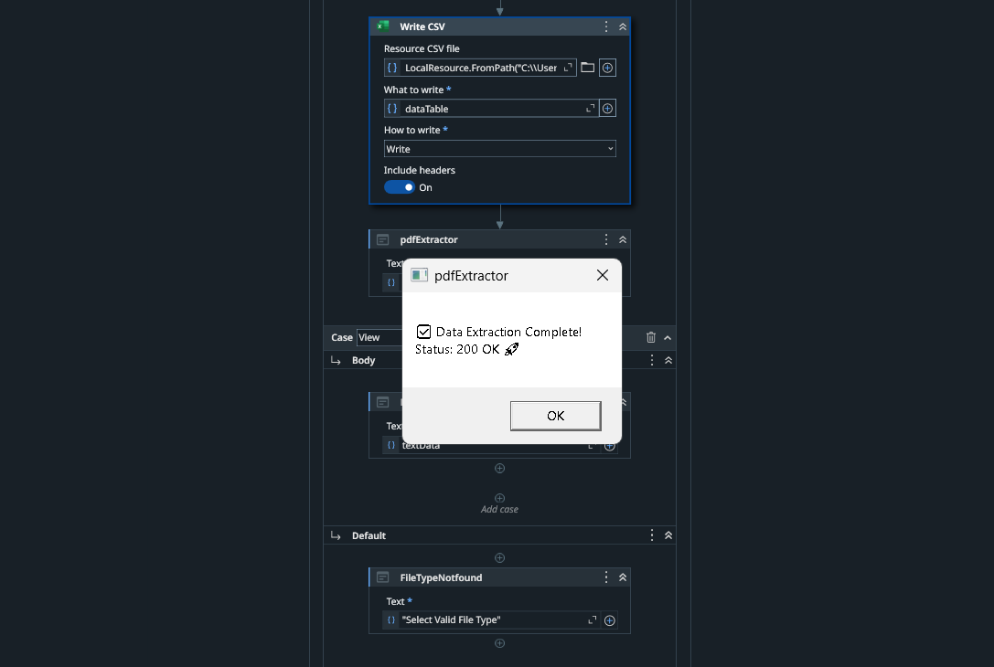

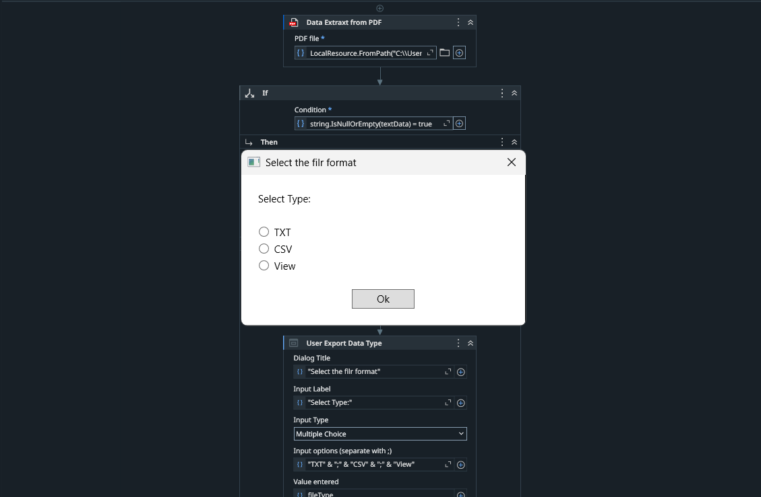

If view then
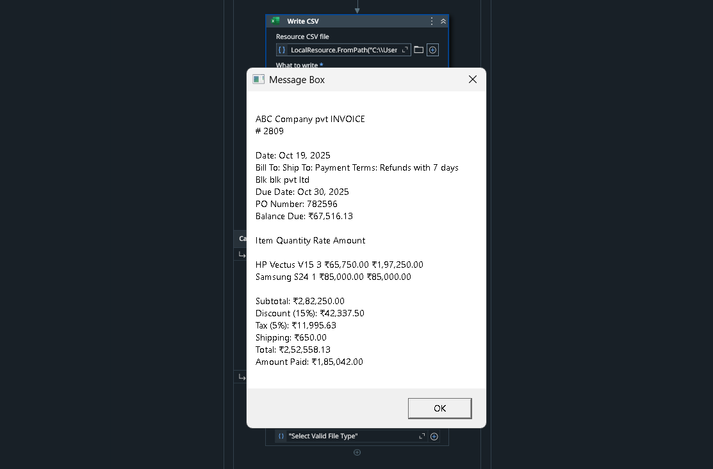

If txt then
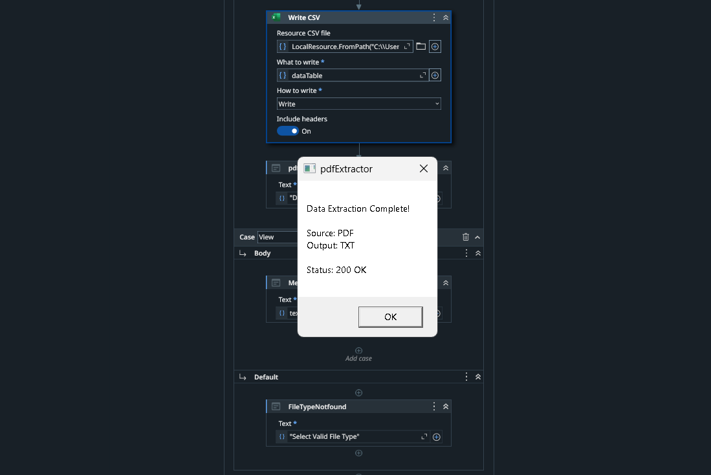

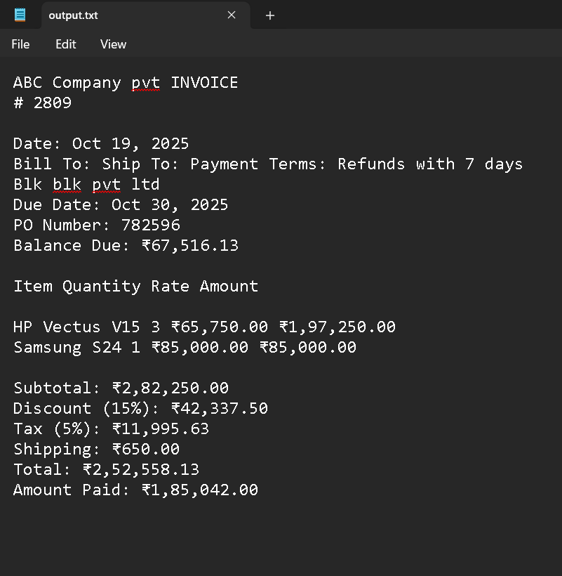

If csv then
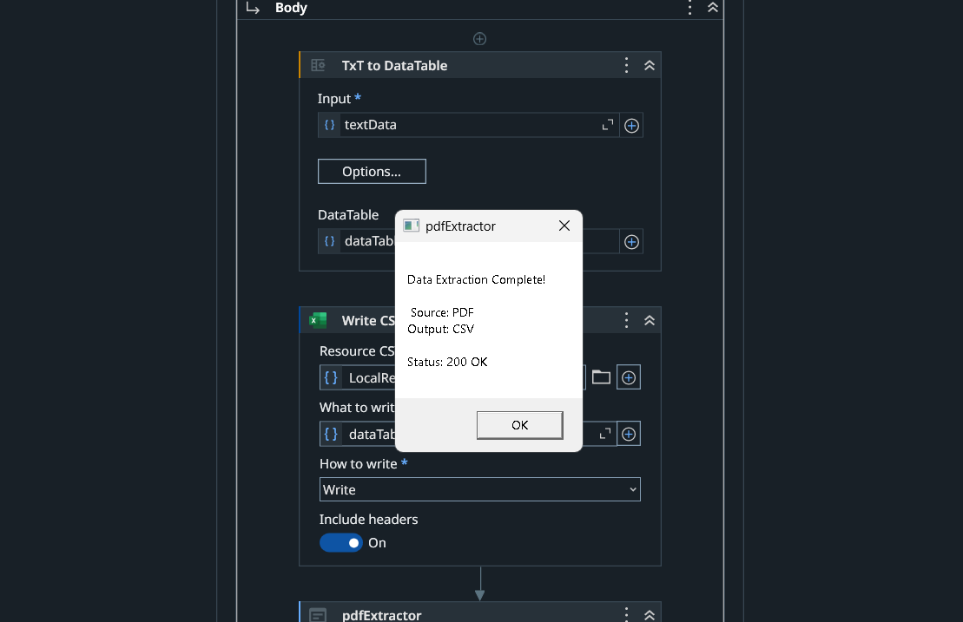

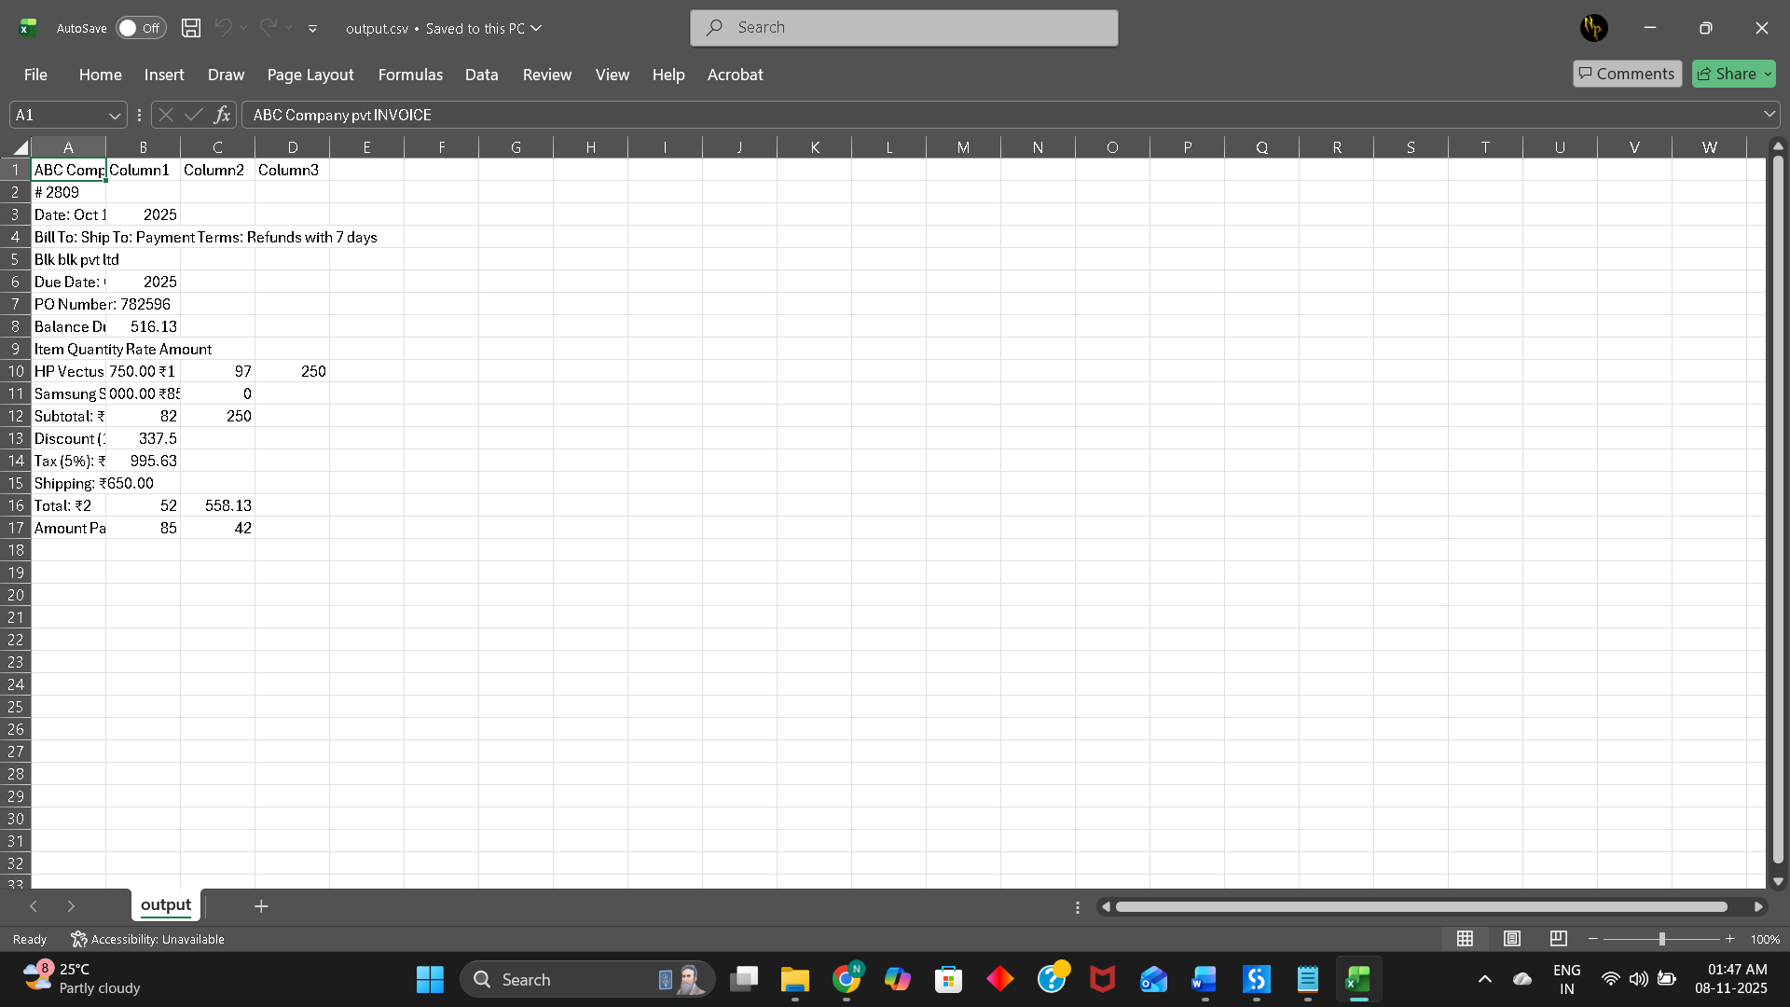

POST-LAB QUESTIONS (Write the answers in your AI and Automation Notebook)
- How are variables and arguments used in UiPath workflows?
Variables store data values within workflows, while arguments pass data between different workflows or processes, enabling dynamic and reusable automation designs in UiPath.

- Explain the purpose of the Assign and Message Box activities.
The Assign activity sets or updates variable values, and the Message Box displays information or output to the user during workflow execution.

- How can automation workflows be published and reused in UiPath?
Workflows can be published to UiPath Orchestrator or local feeds, allowing them to be reused, shared, and deployed across multiple automation projects.

- List any four applications of AI-driven automation across different industries and domains.
AI-driven automation is applied in healthcare (diagnosis), finance (fraud detection), manufacturing (quality control), and customer service (chatbots and virtual assistants).

- Briefly describe the basic elements of an automated system and the benefits of Robotic Process Automation (RPA).
Automated systems include sensors, controllers, and actuators; RPA benefits include improved efficiency, accuracy, scalability, reduced costs, and elimination of repetitive manual tasks.

RESULT:
A basic automation workflow was successfully created and executed using UiPath Studio.
The experiment highlighted the benefits of AI-driven automation and RPA in simplifying repetitive processes.

ASSESSMENT (Write in your lab notebook)
Description | Max Marks | Marks Awarded
Pre Lab Exercise | 5
In Lab Exercise | 10
Post Lab Exercise | 5
Viva | 10
Total | 30
Faculty Signature

